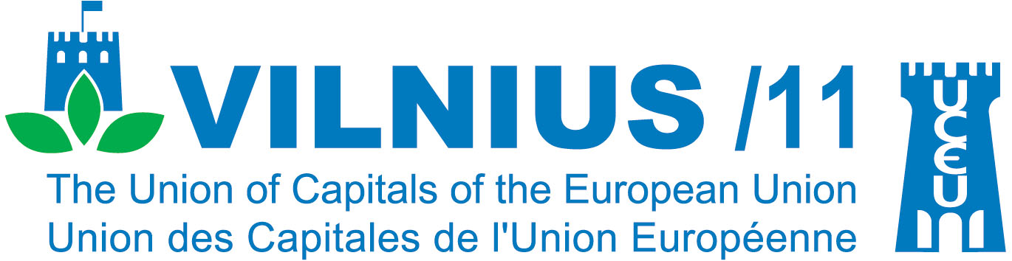

51st UCEU GENERAL ASSEMBLY - CONFERENCE, 14th October, 2011

Vilnius, Lithuania

Cities of the Future

European Capital Cities Creating Low-Carbon Economies and Adapting to Changing Climate for a Sustainable Future

“The fight for sustainable development will be won or lost in our cities.”
Klaus Töpfer, former Executive Director, United Nations Environment Programme (UNEP)

Venue: Vilnius City Municipality (Tarybos posėdžių Hall), Konstitucijos pr. 3, Vilnius, Lithuania

Date: Friday, 14th October, 2011

CONFERENCE AGENDA

Moderator: Mr. Paul Hohnen, CEO Sustainability Strategies, Amsterdam (The Netherlands).

08.30-09.00 Registration

09.00-09.30 Opening Session

Opening of the conference:
Welcome Address: Mr. Artūras Zuokas, Mayor of Vilnius
Greetings from H.E. Mr. Valdas Adamkus, Former President of the Republic of Lithuania

09.30-10.00 Vilnius: A Climate of Change
Presentation on Vilnius city and its achievements in becoming low-carbon and responding to climate change challenge by Mr. Kęstutis Nėnius, Vilnius City Councillor.

10.00–10.30 Cities Leading Change: Global Developments

Presentations on global city/climate change initiatives. Questions and Discussion.

Speakers: Mr. Conor Riffle, Head, Carbon Disclosure Project Cities and Mr. Murat Armbruster, Director of the Green Capital – Global Challenge program, Carbon War Room.

10.30-11.00 Cities Leading Change: Europe in Action
Presentation on Stockholm’s experience of being the First Green Capital City of Europe 2010 by Ms. Linda Persson, Environmental Strategist at the Executive Office in the City of Stockholm, Former Project Manager for the Stockholm European Green Capital.

Presentation on the European Green City Index by Ms. Karen Stelzner, Project Manager, Corporate Communications and Government Affairs, Siemens AG, Munich, Germany.

11.00-11.30 Coffee break

11.30-12.30 Cities Leading Change: Europe in Action (continued)
Presentations/Panel Discussion by UCEU cities on climate strategies and action plans. Presentations will be delivered by the representatives of Helsinki, Riga, Tallinn and Vienna.
Questions and Discussion.

12.30-14.00 Lunch (Venue: Radisson BLU Hotel Lietuva, Conference Center, Beta Hall, Konstitucijos pr. 20, Vilnius)

      - European Capital Cities: Achievements and Outstanding Challenges
Presentation on European Capital Cities coping with climate change – report back analysis of the UCEU survey Questionnaire 2011, presented by Ms. Indrė Kleinaitė, independent sustainability expert, Lithuania.

14.30-15.00 Financing Change: Green Initiatives and Technologies Implemented in Cities
Speakers:
Mr. Murat Armbruster, Director of the Green Capital – Global Challenge program, Carbon War Room,
Ms. Laura Dzelzytė, Climate change adviser and the United Nations Framework Convention on Climate Change (UNFCCC) negotiator, Ministry of Environment of the Republic of Lithuania.

15.00-16.00 The Road Ahead: Conclusions
Reflection on the key issues of the day and final conference document addressed to the European Commission, European Parliament, National Governments and UCEU Cities.
Panelists:
Ms. Radvilė Morkūnaitė-Mikulėnienė, Member of the European Parliament,
Ms. Laura Dzelzytė, Climate change adviser and UNFCCC negotiator, Ministry of Environment of the Republic of Lithuania,
Mayor of Vilnius Mr. Artūras Zuokas, Lithuania,
Mr. Audris Barcevičius, Member of the Board, Siemens Osakeyhtio (Finland and the Baltic states), Lithuania.

Closing remarks by Mr. Paul Hohnen, CEO Sustainability Strategies, Amsterdam (The Netherlands).

16.00 Closing of the UCEU General Assembly Conference.

